# IMAGE PROCESSING

Image Processing is a way to manipulate an image so that we can enhance it and extract useful Information from it. There are very many techniques used to do so in a digital format.

**Image Processing Techniques:**

* **Image Enhancement:**

1. Contrast adjustment is a technique used to increase how visible a certain feature is in an image.

This is achieved by changing and manipulation of the light and darker features of the image by increasing intensity of a certain pixel and decreasing intensity of the others so that the pixel with higher intensity is more contrasted and visible in the image.

1. Noise Reduction is used when a picture seems uneven in its brigthness, contrast making the image difficult to see. In all it is used to smoothen the image methods of filtering are used to achieve this.

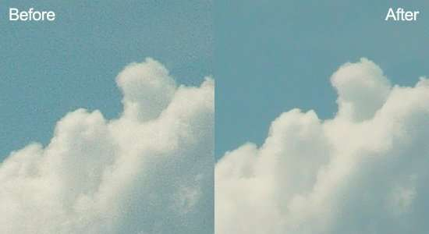

Here the graining in the before picture is the noise which is hampering the image , by use of gaussian smoothing the after image can be achieved.

* **Image Restoration:**

Debluring is used to sharpen a blurry image which could have been caused due a camera shake while taking the picture.

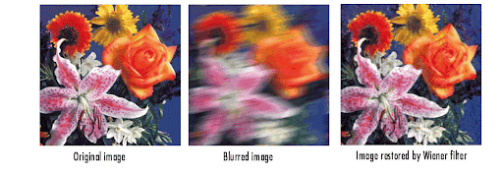

Here the image which has blurred can be deblurred by methods like Wiener filter to almost achieve the same quality as the original image.

* **Feature Extraction:**

It is technique used to extract information from an image by understanding the geometric properties of features in an image. This is also used to detect patterns and recently AI is being implemented to extract text from an image.

**Code Implementation**:(Using OpenCv in python to achieve basic effects)

import cv2

import numpy as np

img_cv2 = cv2.imread('/Synapse/My_Image.jpg')

cv2.namedWindow("Image", cv2.WINDOW_NORMAL)

cv2.resizeWindow("Image", 600, 400)

cv2.imshow("Image",img_cv2)

blur = cv2.GaussianBlur(img_cv2, (5, 5), 0)

cv2.namedWindow("Imageblur", cv2.WINDOW_NORMAL)

cv2.resizeWindow("Imageblur", 600, 400)

cv2.imshow("Imageblur",blur)

kernel = np.array([[ 0, -1, 0],[-1, 5, -1],[ 0, -1, 0]])

sharp = cv2.filter2D(img_cv2, -1, kernel)

cv2.namedWindow("Imagesharp", cv2.WINDOW_NORMAL)

cv2.resizeWindow("Imagesharp", 600, 400)

cv2.imshow("Imagesharp", sharp)

**Output:**

Original Sharpened Blurred

* **Image Compression:**

1. **Loosy Compression:** It reduces the file size of an image by deleting certain information/features of the image. File type such as jpg are already a small file size format but can further be compressed by loss in quality of the image by reducing precision of less noticeable features/Charecteristics.
2. **Lossless Comparison:** Reducing file size without removing/deleting any information. PNG file type can be used for this compression although the compressed file is not as extremely reduced as in lossy compression.

Compressed (lossy) Original

Quality Reduced by 30% of Original (FileSize:195KB 🡪 60KB)

* **Image Format Conversion:**

It consists of three processes:

1. Decompression: The computer reconstructs the pixel data to raw pixel data (data with no techniques applied to it) it converts into frequency values which describes the pixels characteristics in number representation.
2. Before recompression the image exists in a raw form with only three colour channels (RGB) Red, Green, Blue.
3. Compression: The raw pixels are formatted into the target format by its algorithm.